**Ideation Phase**

**Define the Problem Statements**

|  |  |
| --- | --- |
| Date | 31 October 2023 |
| Team ID | NM2023TMID04450 |
| Project Name | Creating a website using canva |

**Customer Problem Statement:**

Create a problem statement to understand your customer's point of view. The Customer Problem Statement template helps you focus on what matters to create experiences people will love.

A well-articulated customer problem statement allows you and your team to find the ideal solution for the challenges your customers face. Throughout the process, you’ll also be able to empathize with your customers, which helps you better understand how they perceive your product or service.

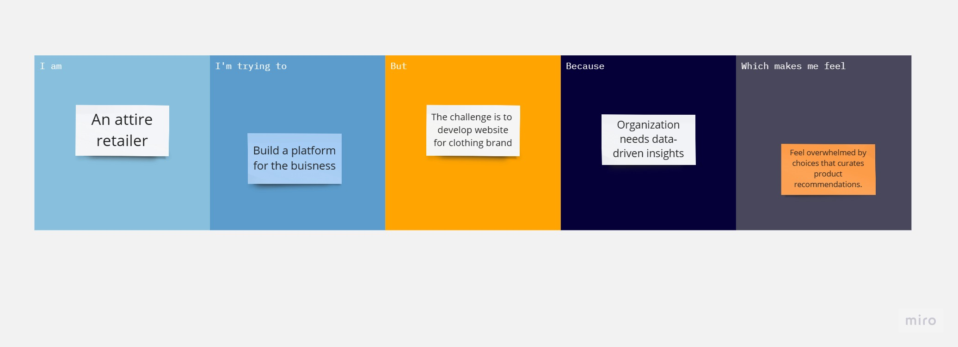

|  |  |  |  |  |  |
| --- | --- | --- | --- | --- | --- |
| **Problem Statement (PS)** | **I am (Customer)** | **I’m trying to** | **But** | **Because** | **Which makes me feel** |
| Problem Statement - 1 | An attire retailer | Build an online platform for our brand. | The challenge in hand is to design and develop visual compelling website. | Organizations need data-driven insights to make informed decisions. | Overwhelmed by choices, and I want a website that curates product recommendations based on my preferences. |